**Apricot DB**

The User Guide

v. 0.5



Contents

Preface 3

What “Apricot DB” does not do 3

Introduction 3

The Project/Snapshot/View concept 4

The Snapshot 5

The View 5

Physical or Logical 6

Entities and Tables 6

How “Apricot DB” stores the Project Data 6

The Elements of the “Apricot DB”- main screen 6

Function: create a new Project 7

The “ApricotDB” Scenarios 8

The Reverse Engineering Process 8

The ERD- graphical notations in “Apricot DB” 10

Entities and Relationships between them 11

The Identifying Relationship 11

The Non-Identifying Mandatory Relationship 12

The Not-Identifying Optional Relationship 12

The “Auto”- relationship 12

Resolving the “many-to-many” relationship 12

The Entity notation 13

Working with the Entities 14

The Default-, Simplified- and Extended- Entity information 15

Working with the Relationships 17

Working with the Views 18

Working with the Snapshots 19

Working with the Projects 21

The Blacklist 21

Generation of the Database Scripts 23

Retrieving the structure of Database in form of Excel table 25

# Preface

“Apricot DB” is a desktop Entity Relationship Diagram tool (the ERD tool). The “Apricot DB”s main purpose is to help its users with the design, analysis, scripting and advance structural visualization of the complex relational databases.

The main presumable audience of this piece of software are the software developers, analysts, database designers, software architects and even some advanced participants of the company’s business processes (how we call them – the business people). They all have been working with the multiple-tables, non-trivial databases and need a tool for the graphic representation of the existing and newly created database structures. The best approaches for the “classic” relational databases are still ERD- tools.

The database structure is a set of tables, connected with each other by relationships (that’s been making the database “relational”). The tables also can be called “entities”. The relatively simple idea of the Entity Relationship Diagram lies in the background of the graphical representation of the database structure.

A list of the essential functions of “Apricot DB” includes the following ones:

* Creation of the general database structure from scratch;  
* Filling all the crucial detailed information for all elements included into the ERD;  
* Generation of all popular types of the SQL- DDL- scripts (create/drop/delete info) for selected or all tables included into the EDR;  
* The Reverse Engineering of the existing database structure into the ERD;   
* Prepare and publish the technical documentation using clear and descriptive graphical representation of the database structure and its fragments;  
* Generation of the Excel Report with the detailed representation of the current EDR information.

# What “Apricot DB” does not do

Even though “Apricot DB” is designed to maintain all major relational databases, it has limitations on working with physical objects specific for concrete database. “Apricot DB” does not support the programmatic structures like triggers, stored procedures and functions.

# Introduction

The “Apricot DB” application is similar to the “classic” IDE’s like Eclipse or NetBeans. The top element of the interface is the Project. There might be any number of the Projects created, stored and maintained in “Apricot DB”, but only one Project can be opened at any particular moment of time.

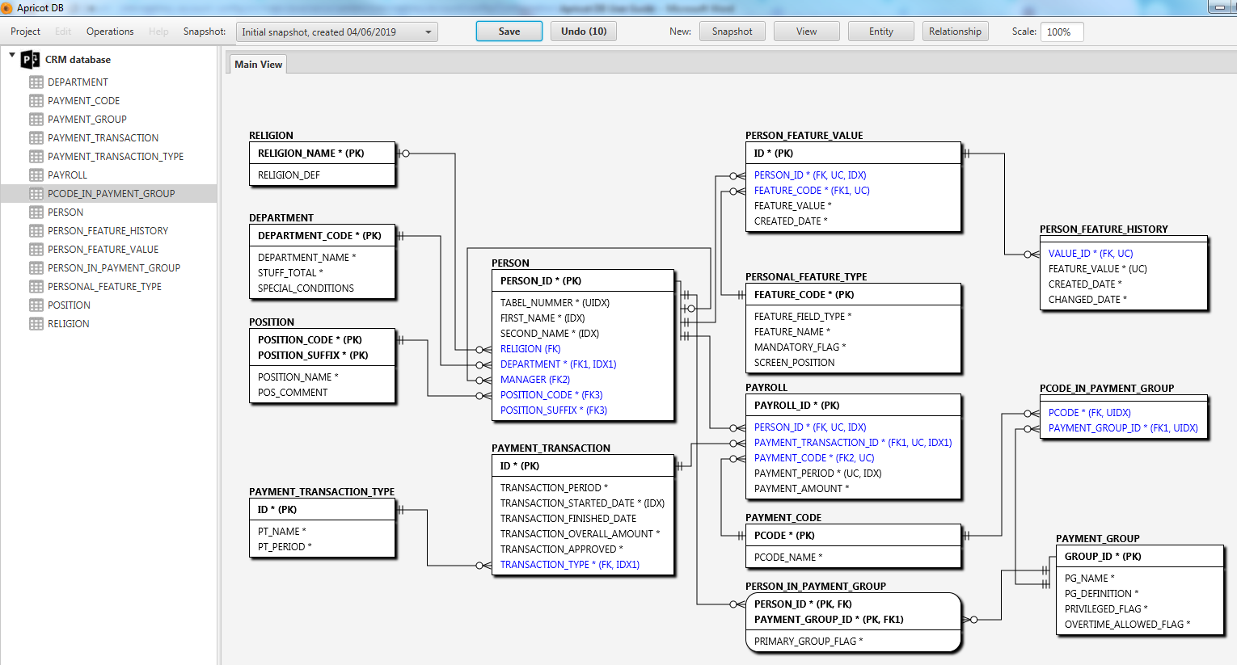

Ideally, one Project is dedicated to one database/schema. In my example (see the screenshot) the project named “CRM database” represents the physical SQLServer database - “APRICOT_TEST”.

The Project contains the Snapshots and Views.

# The Project/Snapshot/View concept

A Project includes the Snapshots and Views. The Snapshot is a container for the Entities and Relationships between them. There might be multiple Snapshots inside one project. This allows keeping different versions of the same database structure.

The Views are responsible for the graphical representation of the database structure. The View can include a subset or the whole set of tables in the current Snapshot. This approach allows splitting one massive database structure into several smaller views, which include only the logically close related Entities.

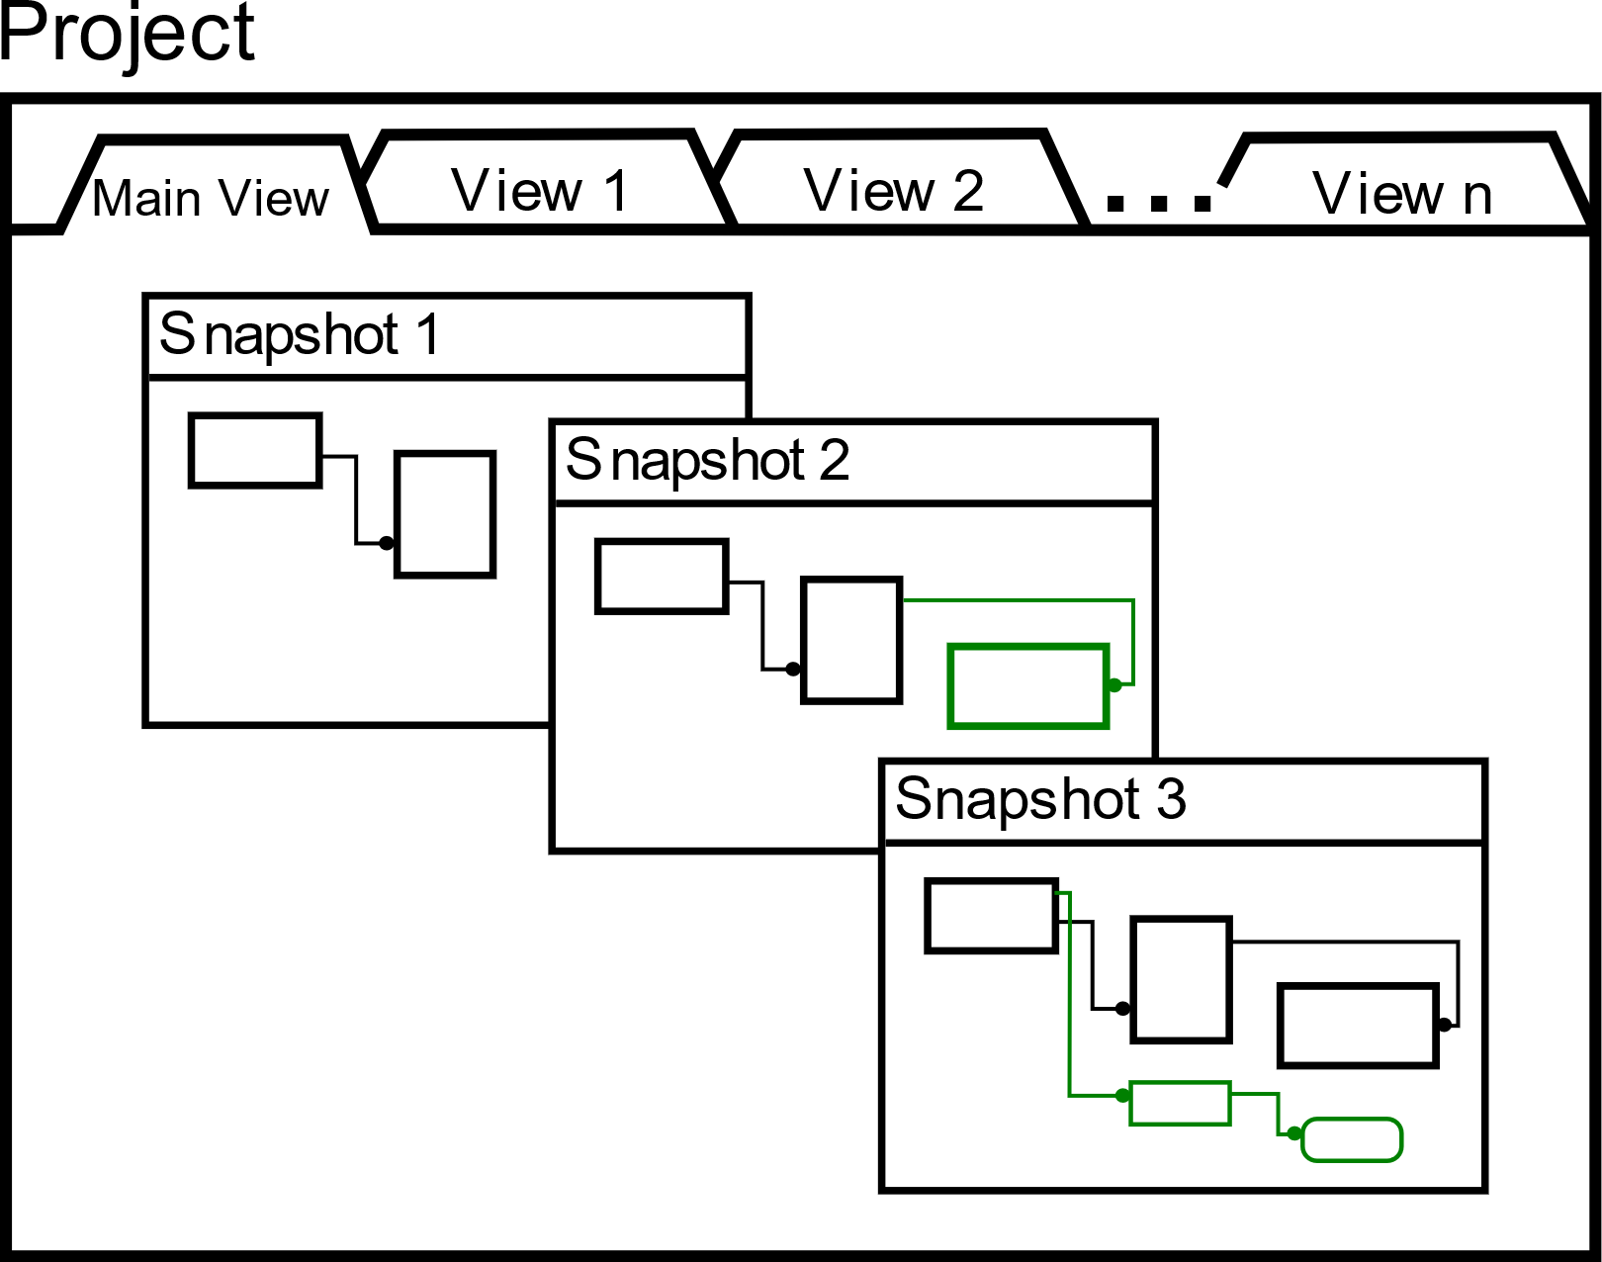

Important notice: One View is applied to all Snapshots included into the Project (the View does not belong to some particular Snapshot). If a new View was created, it will be presented in all Snapshots of the Project. As soon as some change made in allocation of the Entity/Relationships presented in this particular View, these changes will be reflected in all Snapshots. The View in “Apricot DB” can be considered as a “skin”, which has automatically been applied to all Snapshots. Think about the View as a CSS sheet, which is applied to all pages in the Internet Site. As soon as CSS is changed, the look and feel of all pages will change, even though the internal data represented by the pages stay the same.

# The Snapshot

The Snapshot is a main container of the Entities and Relationships between them. The Project has to have at least one Snapshot. There might be any number of Snapshots in one Project. The different Snapshots in the Project might have not equal collections of tables/relationships. The concept of the Snapshot might be considered as a primitive version control system, which stores the objects and the graphical representation of the database structure at the different moments of time. Technically, the Snapshots can have completely different and not overlapping sets of Entities in them. It makes sense though, to stick with the logically the same database structure in all Snapshots of the Project (remember – one Project equals to one database/schema). It allows performing efficiently the comparison between different Snapshots in one Project as well as using an advantage of the View.

# The View

The view contains the graphical representation of Entities/Relationships (see the screenshot above). Do not confuse the “Apricot DB” View with the database views which can been created by CREATE VIEW… DDL command!

There is always one mandatory View included in any Project - “Main View”. It reflects all tables of the chosen Snapshot. The Main View cannot be removed. You cannot exclude Entities from the Main View (you can delete Entities on the Main View, though).

The content of the views other that the Main View can be edited. This means that the Entities can be added or removed from the view at any time.

# Physical or Logical

It is a common practice in ERD editors to distinguish between the logical and physical models. The logical model represents the higher level of abstraction comparing to the physical one. The physical representation usually contains the great details about the physical parameters of the database being designed, while the logical ERD omits the internal details specific only for this particular database.

In sake of simplicity “Apricot DB” does not distinguish between physical and logical schemas. We do not support the pure logical ERD- elements such as many-to-many relationships, the explicit cardinality definitions on the different sides of the Relationship or the logical names of Entities in addition to their physical names (the physical name of the Entity is the name of the corresponding table in database).

All the Relationships in “Apricot DB” are of “one-to-many” type.

# Entities and Tables

The Entities are elements of the ER- diagram. Each Entity corresponds to the table in the target database. In this document I use terms Entity and Table as synonyms.

The Attributes within Entity have been corresponding to the fields of the database table. I use terms “attribute” and “field” as synonyms.

# How “Apricot DB” stores the Project Data

The Projects, Snapshots, Entities, Relationships, Constraints and Attributes have been stored by “Apricot DB” in the special database - the Project Database. The Project Database is a binary file, stored on the local disk.

On every run of “Apricot DB” it restores the most recent condition in the current Project.

# The Elements of the “Apricot DB”- main screen

The “Apricot DB” use interface is shown on the screen shot below. The interface contains the following elements:

[1] The Project Explorer – contains a list with all Entities in the current Project. The Entities which have been included into the current view (not the Main View) will be shown in bold;

[2] The Views Tab – all the views created for the current Project have been accessible via these tabs. The most left view is always the Main View;

[3] The “canvas” – the main “drawing” area of the current ERD (corresponds to the current view). This is where the user of the application is “drawing” the Entity Relationship Diagram.

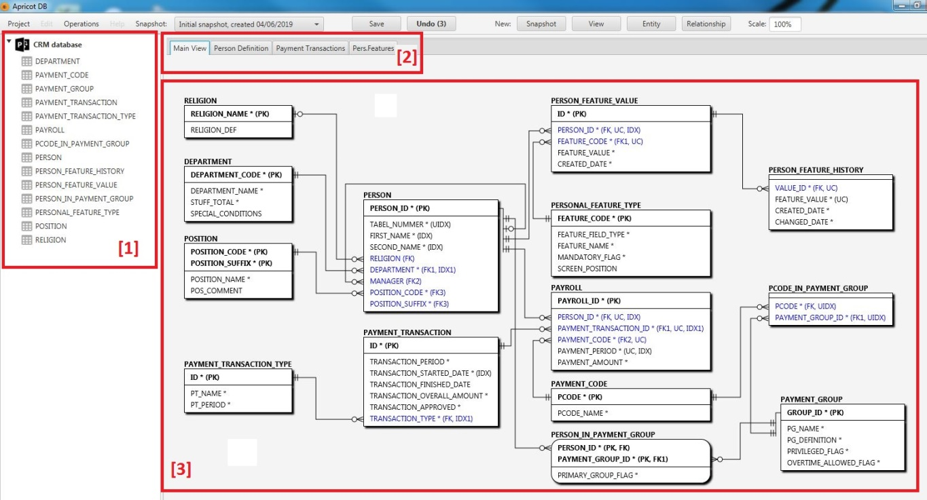

The task bar on the top of the application screen contains the following elements: 

[1] The main menu;

[2] The Snapshot switch and editing tool;

[3] Save/Undo buttons, to save and undo the changes in positions of the ERD elements;

[4] These buttons create the new elements in the current Project: Snapshots, Views, Entities and Relationships.

# Function: create a new Project

In order to create a new Project, use menu Project/New in main menu:

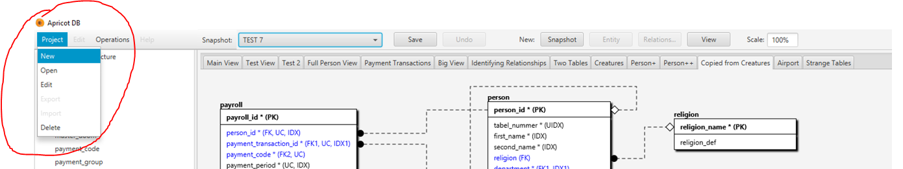

The form of creation of the new Project is shown below.

The Project has the target database type associated with it (see the drop down list “Project Database”). The database type might be changed any time.  
The ERD Notation might be selected during the new Project creation or later on.  
The Project Description is optional.

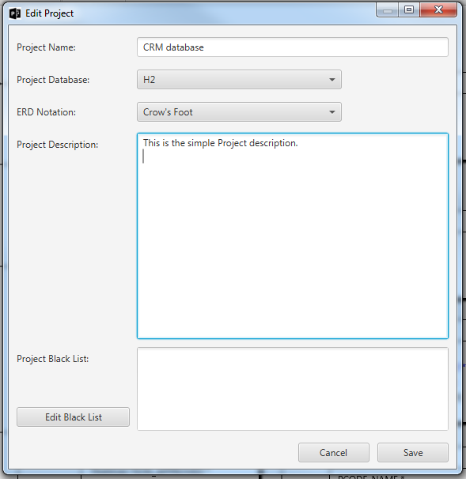

By default “Apricot DB” creates an empty Snapshot – “Initial snapshot created <on date of creation>”. The default name of the initial Snapshot can be changed later. The only view after the creation of the Project from scratch is the Main View. This view is empty since there is no entities in the project yet.

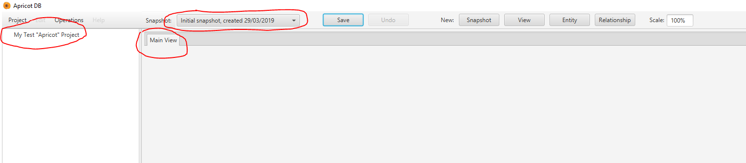

# The “ApricotDB” Scenarios

There are two main scenarios of working with “Apricot DB”:   
* The Entity/Relationships in the current Project needs to be created from scratch;  
* The database structure needs to be red from the existing database. This process called Reverse Engineering.

# The Reverse Engineering Process

Use menu Operations/Reverse Engineering to start the Reverse Engineering process:

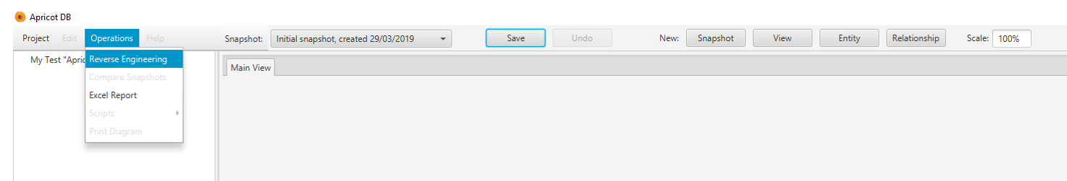

The form of connection to the Database depends on the database type (see the Project parameters above). Below the example of the SQL Server connection form is shown:

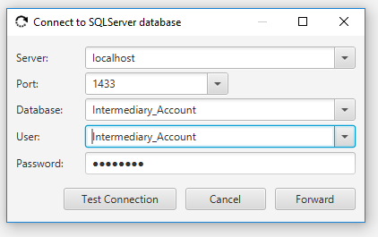

If the connection to the target database was successful, Apricot DB scans the database structure and offers a list of the tables found:

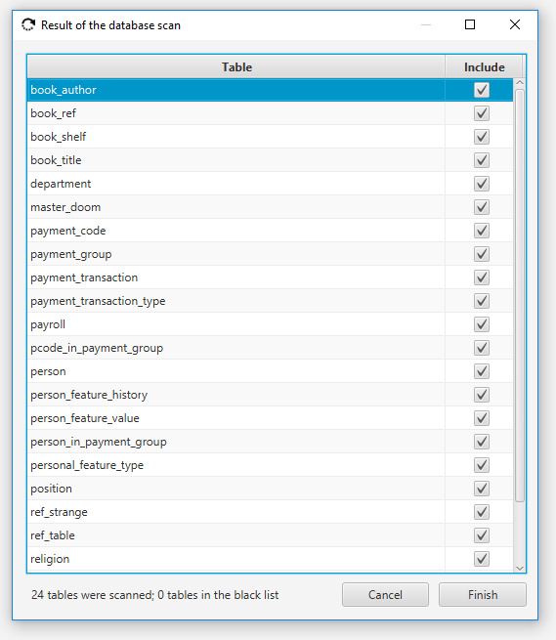

The selected tables will be added into the current Snapshot. Any tables in the list can be excluded from the resulting set on this stage (uncheck the flag “included”).  
Note: Unchecking the tables in the “Include” list, excludes them from the resulting set. This operation has potential risk of violation of the referential integrity of the resulting ER Diagram. In order to prevent that, “Apricot DB” analyses the referential integrity existing in the current database schema. The warning is issued if any potential integrity violations were identified on this stage. For example, there is a table “A” and it is a parent of the tables “B” and “C”. If the parent table “A” is excluded from the result, the tables “B” and “C” have to be removed as well. Otherwise the tables “B” and “C” would have the foreign keys with no Primary Key, related to them.

If the potential violation of the referential integrity was found, “Apricot DB” issues a warning in the flowing form:

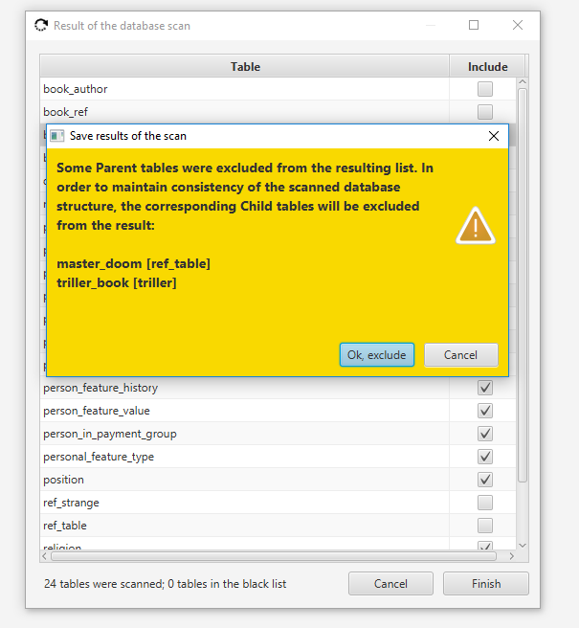

If the user accepts the suggestion given by the application, the related tables will be removed from the result as well. This helps to keep the database structure consistent at any moment of time.

That’s how the initial structure, red from the database looks like after the Reverse Engineering process:

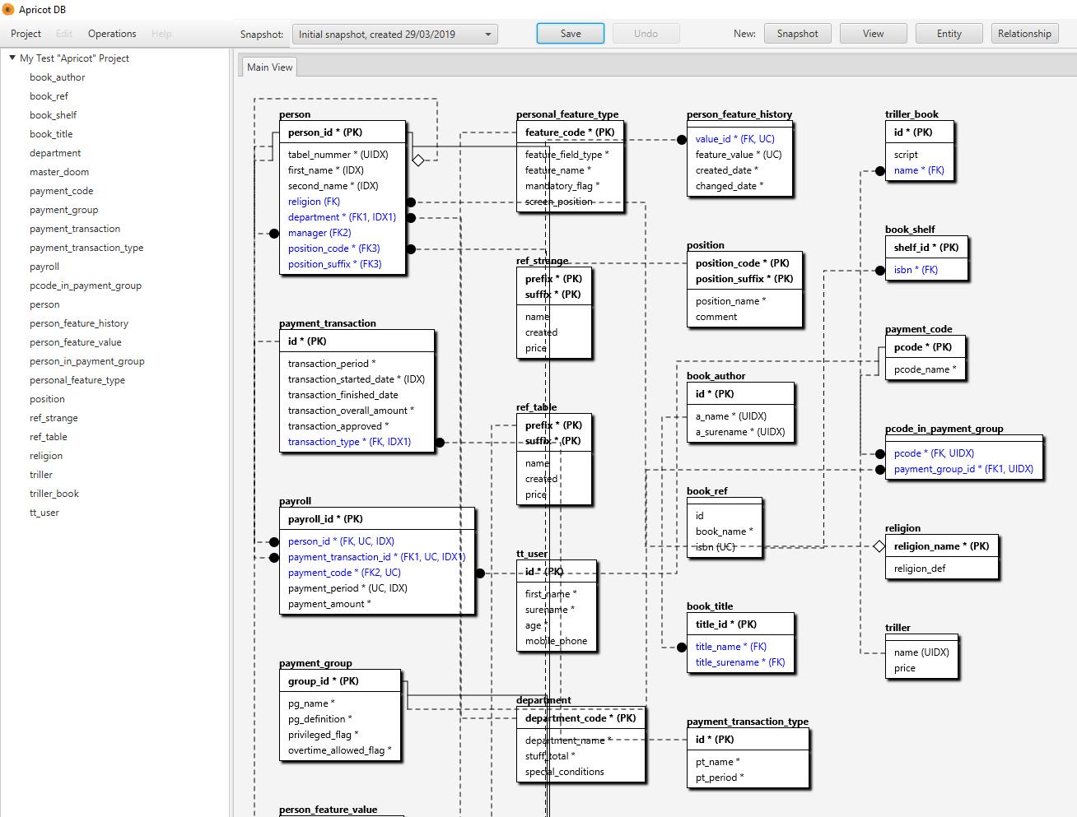

(note: the current default layout is simplified and will be improved in the forthcoming versions of the app).

# The ERD- graphical notations in “Apricot DB”

“Apricot DB” supports two ERD notations: The “Crow’s Foot” and the standardized notation IDEF1x. The “Crow’s Foot” notation is very popular nowadays. It is a primary notation in Apricot DB.  
The IDEF1x standard ERD notation is very intuitive, but less popular than the “Crow’s Foot”.   
In order to switch between notations use the Edit Project form (menu Project/Edit).

## Entities and Relationships between them

The Entities on the ER- diagram are connected with Relationship (there might be the stand-alone entities, which have been by themselves and do not have any relationships with others).

In the Relationship below, the Entity on the left side called “Parent”. The Entity of the right side called a “Child”. In other popular terminology they would be “Master” and “Slave” respectively.

The “Crow’s Foot” notation:

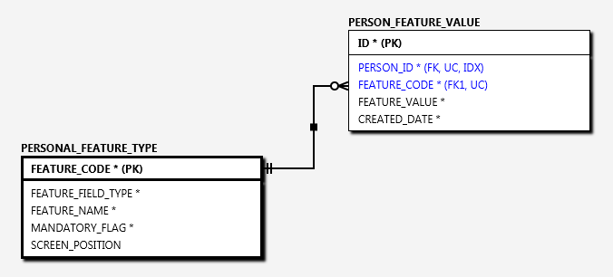

The IDEX1x notation:

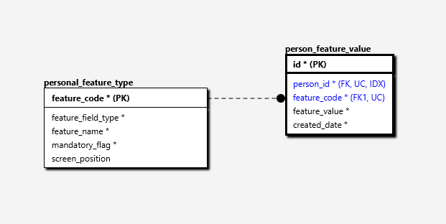

They say that the Primary Key of the Parent is exported to the Child. The corresponding field of the Child Entity called the Foreign Key.

Often the Parent entity acts as a reference or detailed entity. They say that the Child Entity refers to the Parent.

There are 3 types of the relationships between Parent and Child.

## The Identifying Relationship

…takes place when the Parent’s Primary Key is included into the Child’s Primary Key. The Identifying Relationship has been drawn as a solid line:

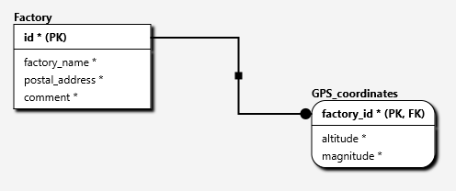

## The Non-Identifying Mandatory Relationship

This type of relationship takes place when the Parent’s Primary Key is linked to the mandatory field on the Child- side. The notation for this type of Relationship is shown below:

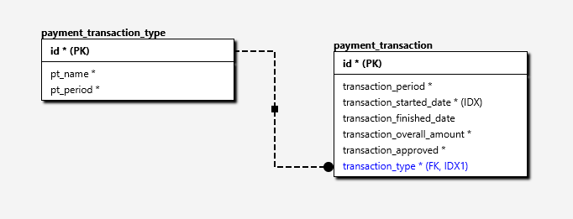

## The Not-Identifying Optional Relationship

This type of relationship exists if the Foreign Key field on the Child- side is optional.

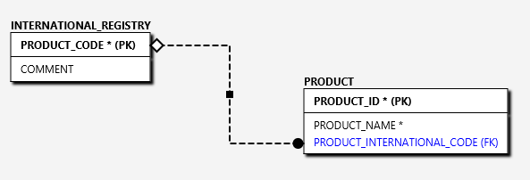

The field “PRODUCT_INTERNATIONAL_CODE” in the table “PRODUCT” on the fragment of the diagram above is optional. Therefore, the relationship is Not-Identifying Optional.

## The “Auto”- relationship

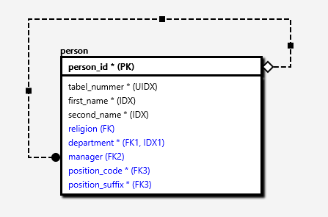

The Entity can be referring to itself. For example, on the diagram above the entity “person” has the “auto”- relationship between “person” and “manager”. The “auto” relationship is always Non-Identifying. It can be mandatory or optional.

# Resolving the “many-to-many” relationship

As it was mentioned earlier, “Apricot DB” does not provide the direct support of the “many-to-many” logical relationship.

In order to implement the “many-to-many” relationship, an additional entity needs to be introduced, so called “Association Entity”.

The “Association Entity” is shown on the diagram below and marked in yellow.

This “many-to-many” resolution was implemented using the identifying relationships on both sides.

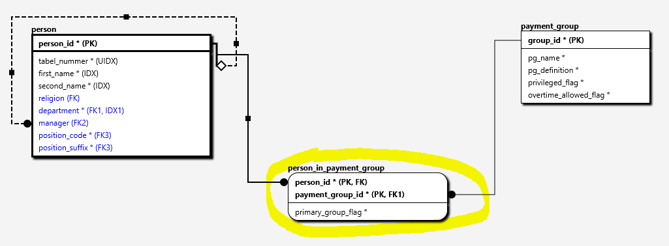

Alternatively, the “many-to-many” relationship can be resolved using the non-identifying relationships, as it is shown below:

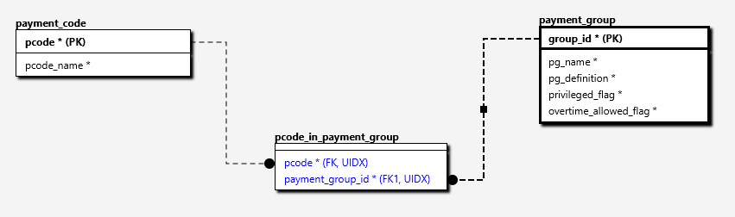

# The Entity notation

The entity on the ERD- diagram contains fields. The asterisk symbol means that the table column is mandatory. On opposite, when no asterisk is set, this would be an optional column.

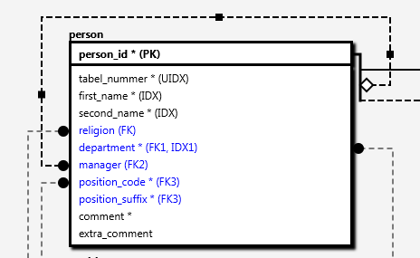

The columns might have the following additional property identifiers:  
PK – the Primary Key;  
FK – the Foreign Key;  
UIDX – the Unique Index;  
UC – the Unique Constraint;  
IDX – the Non-unique Index.

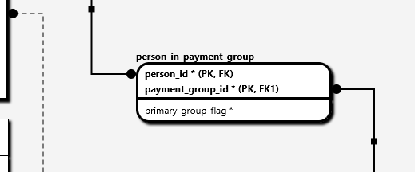

If multiple constraints are applied to the same Entity, they will be marked as 1, 2 and so on. Example: FK1, FK2, FK3. The tip with information about the field type will pop-up, when the mouse is positioned over the field.

The Child- Entities with Identifying relationships has round corners.

# Working with the Entities

The key element of any ERD is an Entity.



In order to create a new Entity, use the item “New Entity” on the toolbar, as shown above.

The form of creation/editing of Entity contains two tabs: “Columns” and “Indexes and Constraints”.

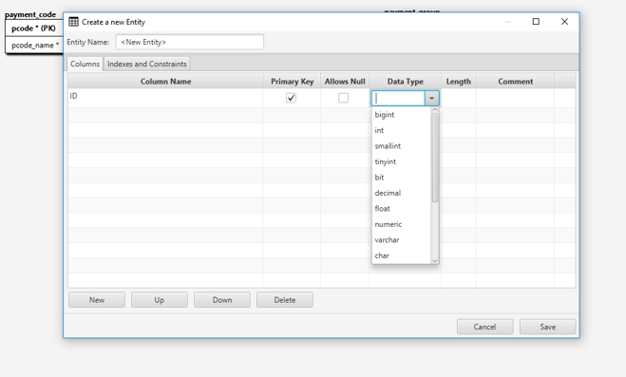

The names of fields in the table above are self-explanatory. The set of types, presented in the drop-down menu “Data Type” is a database specific. This list includes only most popular types, specific for the target database type. If user needs some type which is not included into the provided list, the new type can be entered manually into the “Data Type” field.   
Note: the type of the target database is set for the current Project during the project-create procedure. The Project’s database type can be changed at any time.

The sequence of columns in the “Columns” grid will be used for generation of the database create- script. This will be the physical sequence of the columns then. The column can be moved up and down in the sequence.  
The “Indexes and Constraints” tab.

Here user can add/edit the Entity- constraints and indexes.

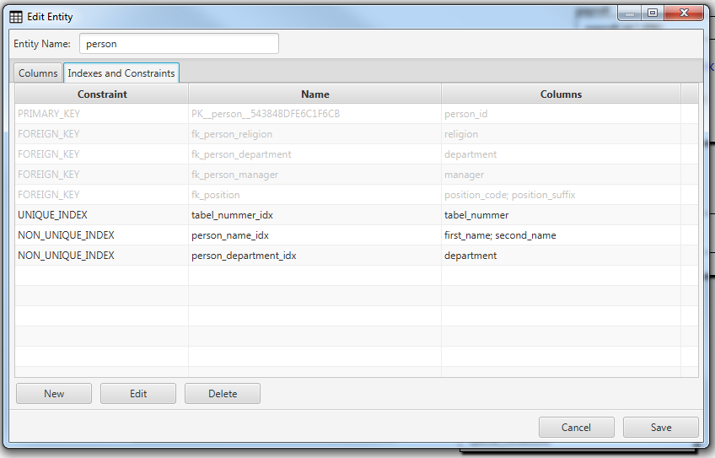

The create/edit constraint form id shown below. The fields, included onto the constraint can be added/removed.

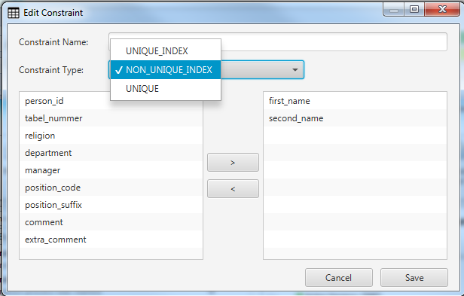

The Primary and Foreign Key constraints are not editable in the “Indexes and Constraints” tab. They have been created automatically, when the Primary Key is described in the “Columns” tab, or the Relationship is established between Entities.

The Entity can be removed at any moment of time. The <DEL> button deleted Entity. If entity being deleted has relationships, these relationships will be removed automatically together with the Entity.

To edit Entity double click of it either in the list of Entities of the left- side, or on the Entity image in ERD.

# The Default-, Simplified- and Extended- Entity information

The diagram might be operatively reconfigured depending on the level of required details.

In order to switch between different level of Entity information use the content menu anywhere in the drawing field of the diagram (the right mouse button click):

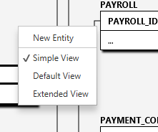

The “default” level of details presents the fields of entities without types:

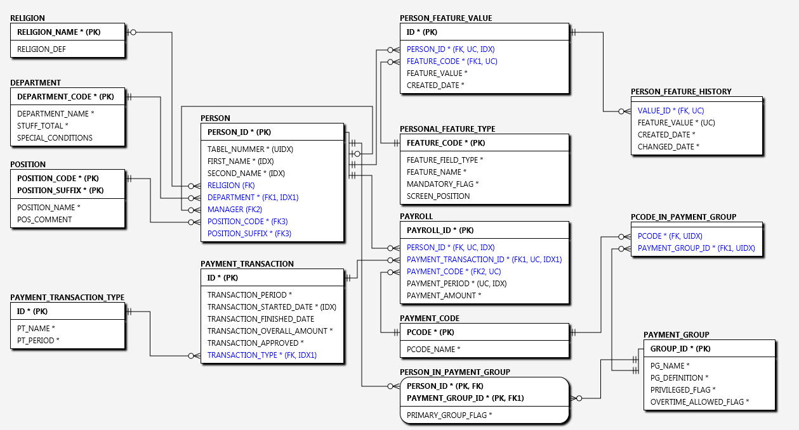

The “simplified” view contains only the primary key attributes, omitting the non-key attributes:

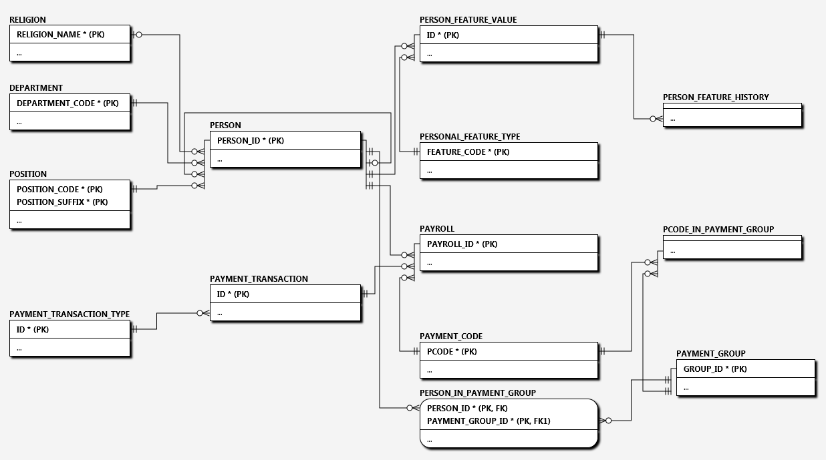

The “extended” view reflects the attributes type information:

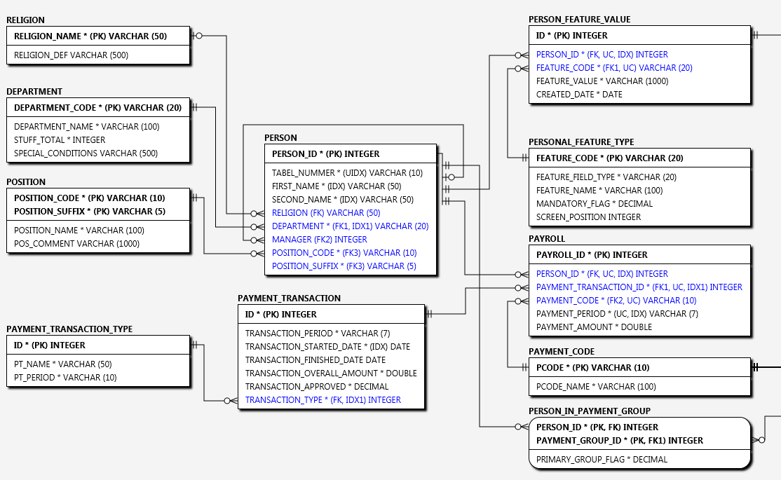

# Working with the Relationships

In order to create a new Relationship between Entities, one or two entities have to be selected. Then use “New Relationship” button:

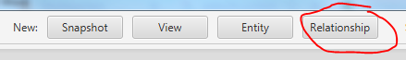

If only one entity was selected, the new relationship will be an “Auto”- Relationship (the Relationship which links the Entity with itself).

The new Relationship form is shown below:

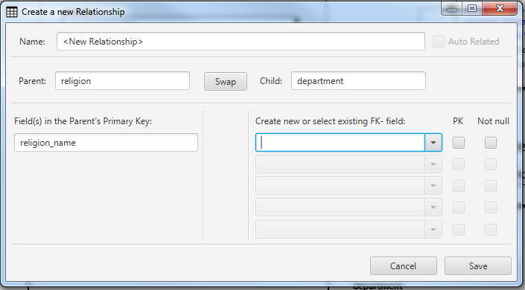

It is important to choose properly the Parent and Child tables in the pair of Entities. A Parent is always allocated on the left side. A Child is allocated on the right side.

The fields shown on the Parent side are included into the Primary Key and provided by the form automatically. The fields on the Child side have to be explicitly entered.

There are two options for the editing of the Child- fields:  
* create a new field, linked to the foreign key on the Child- side. In this case, the field name has to be entered into the form. Type of the newly created field is dictated by the corresponding field in the Primary Key of the Parent Entity. If the “PK” option is chosen, the new Relationship will be Identifying. If the new field is set as “Not Null” (and not “PK”) – this will be the Non-Identifying Mandatory Relationship, otherwise - Non-Identifying Optional Relationship. The Primary Key is always not null;  
* choose an existing field of the Child- Entity from the drop down list. In this case the chosen field of the Child- Entity will be included into the Foreign Key newly created.

There is no “Edit” functionality for the Relationship. To alter the relationship, it has to be deleted and created from scratch.

# Working with the Views

The View is a logical fragment of the main ERD. It includes a subset (or all) tables of the current Snapshot. Usually the tables, included into the View have been logically united.

There are 3 main options when a new View is being created (see the options in “Initialize From” section of the form):  
* Empty – in this case, the Entities, included into the View have to be selected manually. The list on the left side of the form contains all Entities, contained in the current Snapshot;  
* Selected – the View will contain the selected entities of the current active View;  
* View – the new View will be initialized with all entities of the selected view (the reference view needs to be selected from the drop down list.

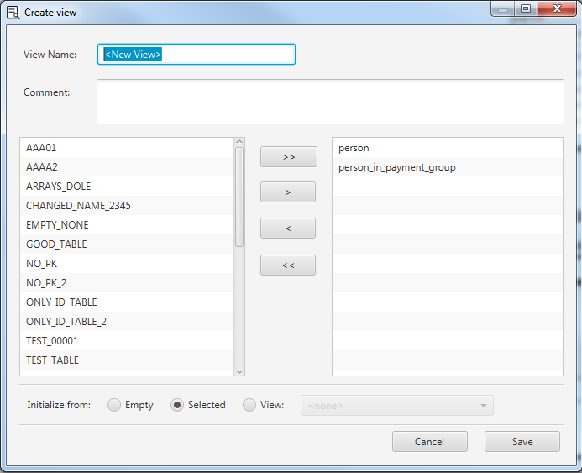

As it was already mentioned above, the View belongs to the whole Project – not to the current Snapshot. It means, that any changes in the View reflect in other Snapshots as well. This needs to be taken into account while working with “Apricot DB”.

One View – the “Main View” is not editable and always includes all tables of the current Snapshot.

Any alterations of the Entites/Relationships including the new or removed columns, created or deleted Relationships, made in one View, immediately reflect in all affected Views.

In order to edit or delete the View, use the right button mouse click over the View’s tab. The following context menu is shown below:

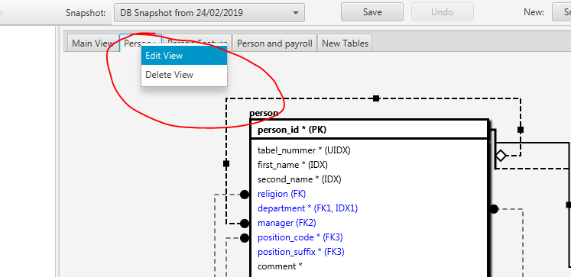

# Working with the Snapshots

The Snapshot is a container of the Entities/Relationships. A Project can contain multiple Snapshots. The main idea under the Snapshot is to allow storing the multiple versions of the same logical database. For example, some project needs to support/develop several versions/modifications of the same database. “Apricot DB” allows to generate the “CREATE”- scripts from any Snapshot, as well as compare different snapshots and generate the “difference” DB- scripts, which can be used to align one snapshot (the source) to another (the target Snapshot).

To create a new Snapshot use “New Snapshot” button on the toolbar:

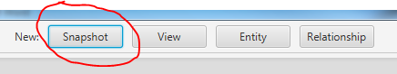

The new Snapshot can be created empty (see “Initialize from” section of the form), or from other Snapshot. The first option is useful when the ERD has to be created from scratch. Another application of the empty Snapshot would be the Reverse Engineering- operation. The Reverse Engineering of the existing DB- structure has to be performed into the empty Snapshot.

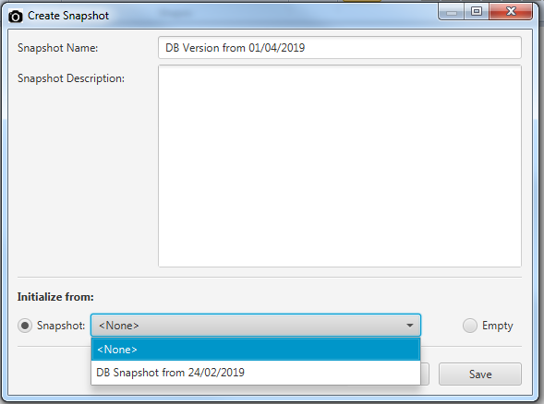

Another option of creation of the Snapshot is to create Snapshot from the reference one. This option is useful, when user needs a new version of the database structure and wants to save the original one.

The current Snapshot can be changed at any time, selecting from the drop down list show below:

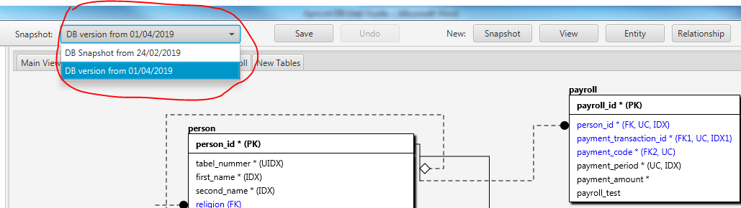

When the Snapshot is chosen it automatically becomes the default one. Next time, when the application is started, the latest selected Snapshot has been active and ready for work.

In order to edit the Snapshot name or description or delete Snapshot use the menu “Snapshot:” as shown below:

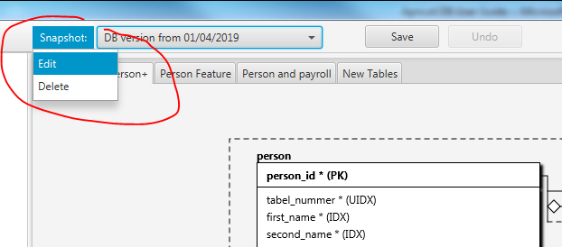

# Working with the Projects

The Project is a top of the “Apricot DB” hierarchy. It is recommended to create a dedicated Project for the logically consistent database structure. For example, the user- schema in Oracle can be considered as such a database structure. Another example is the Database in SQL Server.

A new Project can be created using the menu item: Project/New.

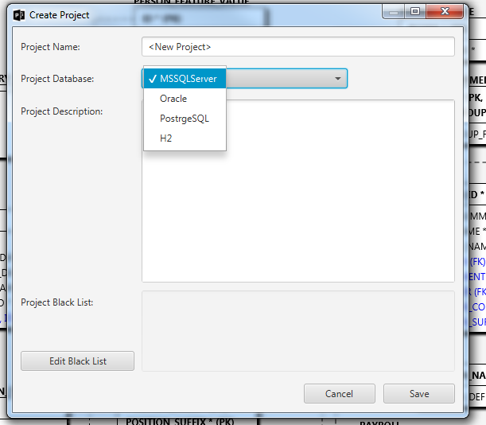

The Project should have a unique name. The Project Database has to be chosen from the drop down list. The Project Database is important for the Reverse Engineering. Different database types have different connection options and algorithms of scanning of the source database structures.

The Project Description is mandatory and can contain the Project- related comments in the free format.

All fields in the Project form can be edited after the Project is created, if needed.

# The Blacklist

If database schema, which is being scanned, contains the tables which have to be excluded from the resulting entity set, the Blacklist can be used.

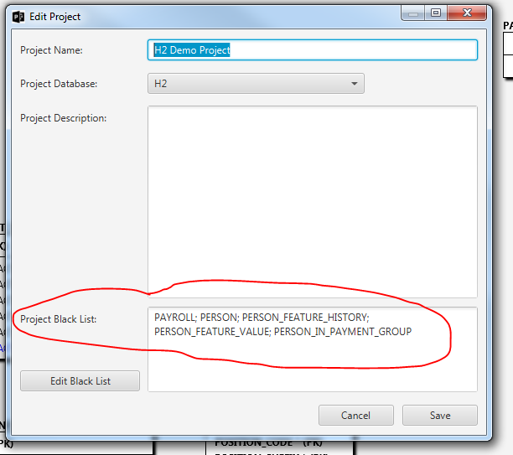

The Blacklist can be populated in two ways: explicitly via the form of editing of the Project (use the “Edit Black List” button). The entities, included into the Blacklist have to be “moved” to the right- side as shown on the screen below:

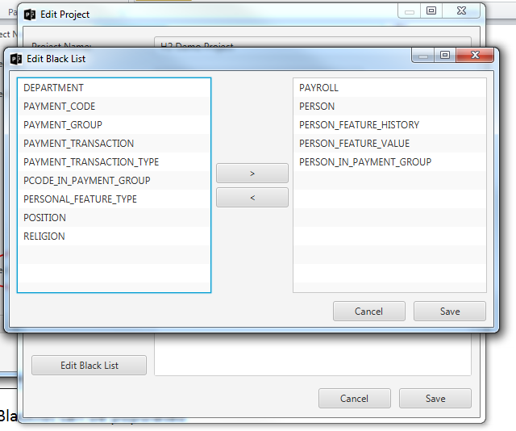

The Blacklist can be edited in this form.

The second option for the population of the Blacklist is the following: if, during the Reverse Engineering process, some entities were excluded from the resulting list, they would be automatically included into the Blacklist. As it was mentioned above, the Blacklist can be edited.

If some entities were included into the Blacklist, in all the subsequent Reverse Engineering procedures these entities will be unchecked as shown on the screenshot below:

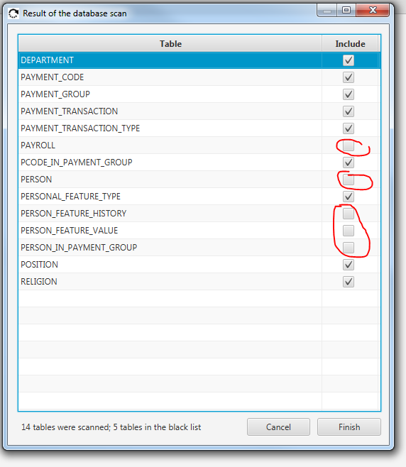

This means that “Apricot DB” scans the whole list of the tables in the source database, but uses the Blacklist and “suggests” excluding the previously excluded tables from the result set. User can check the unchecked entities in the form above, and they will be included into the Reverse Engineering result.

# Generation of the Database Scripts

There are 3 types of database scripts which can be generated by “Apricot DB”:

1. Create Script – a script which purpose is to create all objects, presented on the current ER- diagram;
2. Drop Script – script for consistent dropping of the chosen database objects;
3. Delete Script – script which allows deleting data from the chosen tables (entities).

The Generate Scripts functionality is available through the main menu:

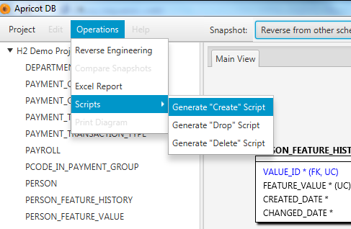

The script generation form is shown below (this form is common for Create, Drop and Delete types of scripts):

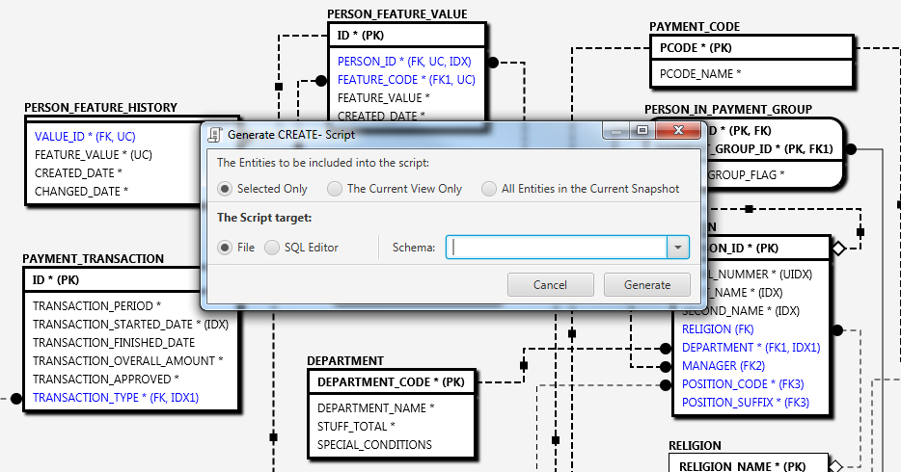

In this form a set of parameters can be changed. If some Entities were selected in the current view the “Selected Only” option for the entities, which will be included into the resulting script.

“Schema” is an optional parameter. If schema is filled in, it will be included as a prefix for the table names.

The resulting script might be written directly into the file on the disk, or shown in the simple SQL Editor:

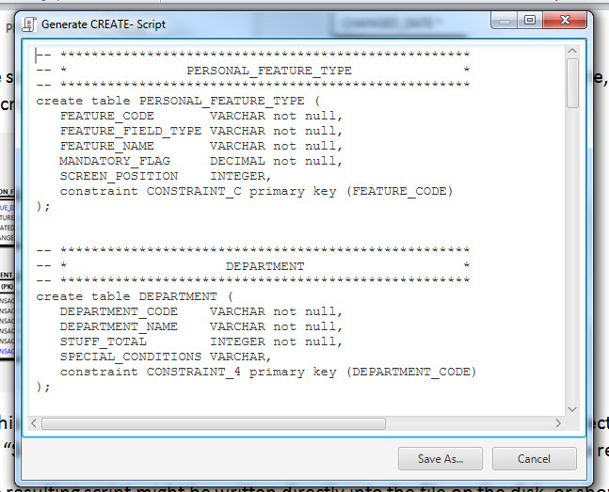

To run the resulting script on the target Database, use your favourite data access and administration tool (DB Visualizer?).

# Retrieving the structure of Database in form of Excel table

There is a special feature, provided by “Apricot DB”. The Entities/Relationships in the current Snapshot can be requested in the form of an Excel sheet. Use “Operations/Excel Report” to generate this report:

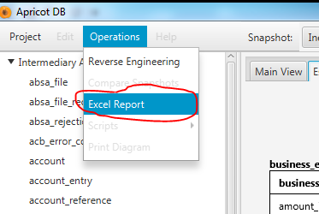

The resulting Report contains two tabs. The “Tables List” represents the whole list of Entities in the current Snapshot sorted alphabetically.

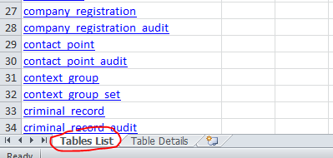

These table names have been generated as the hyperlinks which lead to the second tab of the Excel sheet: “Table Details”:

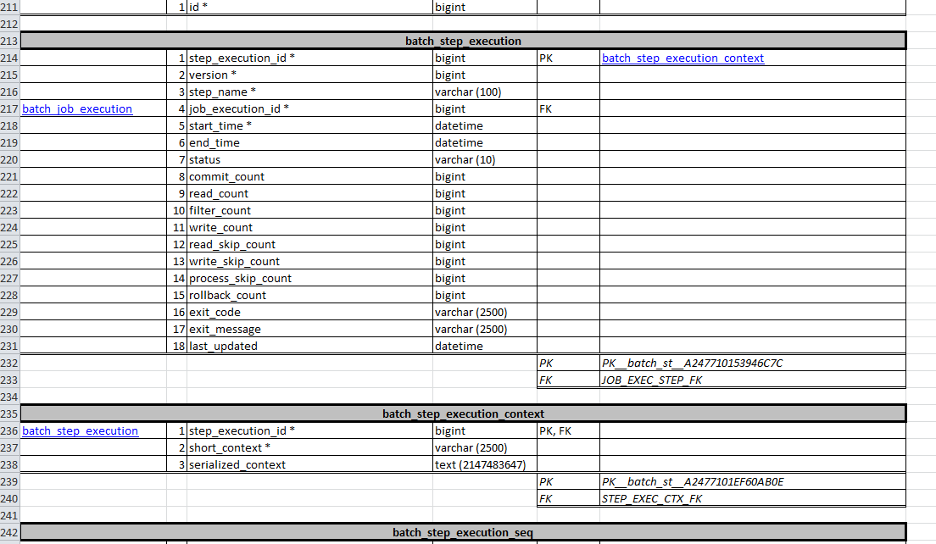

The “Table Details” tab contains extended information for each table in the list. It includes names, types, nullable feature and so on (see the screenshot).

Tables which participate in the Relationships there will be hyperlinks leading to the related tables. The hyperlink on the left side stands for the Parent of this table. Hyperlinks on the right side point to the tables, for which the focused table acts as a Parent.